Titanic Logistic Regression Model Analysis Report
Name: saman axel noel kple Student ID: 301481950
Introduction
This analysis examines the Titanic passenger dataset (containing 891 individuals across 12 columns) and develops a logistic regression model intended to forecast passenger survival. The project involves data exploration, visualization, cleaning, and normalization, along with fitting models, performing 10-fold cross-validation across multiple train/test sets, and assessing performance at two decision levels.
b.4 Columns not useful for the model
- PassengerId – a unique row identifier with no predictive meaning.
- Name – unique text per passenger; cannot generalize to unseen passengers.
- Ticket – almost entirely unique alphanumeric codes, so it carries little reusable signal.
- Cabin – only 204 of 891 values are present (~77% missing), too sparse to impute reliably.

c. Visualization conclusions

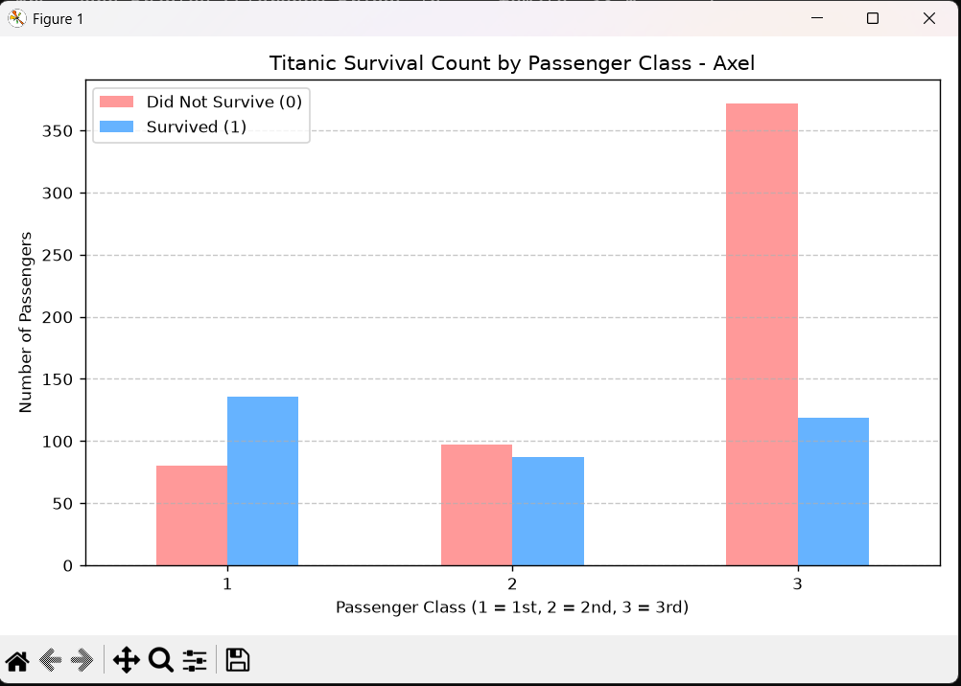
Survival by passenger class: first-class passengers were the only group where more people survived than died. Third class had by far the most passengers and the highest death count (roughly 372 of 491 died), so survival chances fell sharply with class.
Third class had the highest number of passengers and the highest death toll (approximately 372 out of 491 succumbed), leading to a significant drop in survival rates based on class.

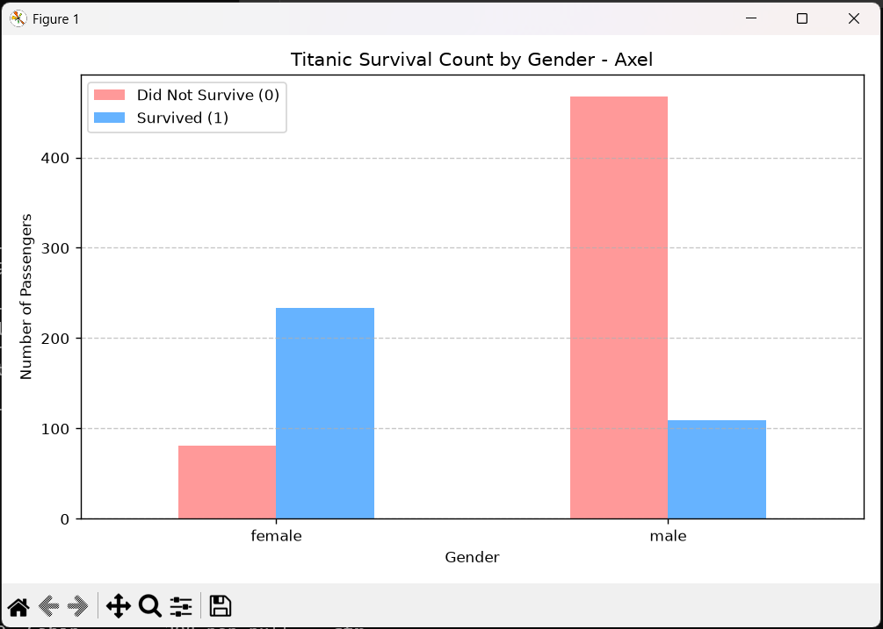

In terms of survival, women were significantly more likely to make it (233 out of 314 compared to 109 out of 577), aligning with the evacuation policy that prioritized women and children.

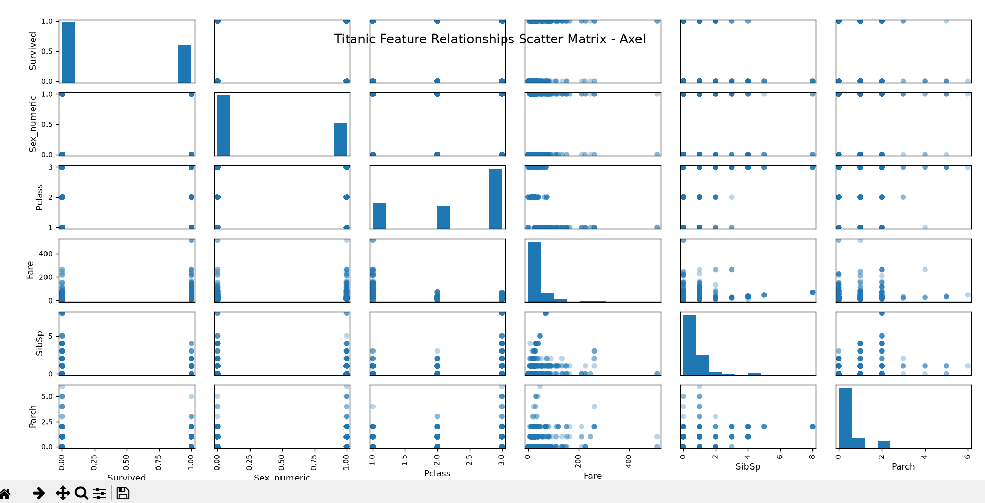
Scatter matrix: For Survived, which is binary, the plots display two distinct horizontal bands. Higher fares and more affordable classes are associated with survival; most very high fares are among the survivors. Small counts of SibSp and Parch show little pattern, though passengers with very large families tend to appear mainly among non-survivors. There appears to be a clear relationship between fare and Pclass, suggesting some collinearity.

d.12 Histogram – Port of Embarkation

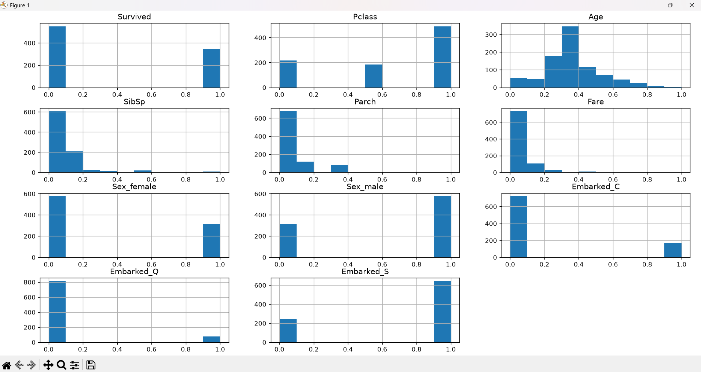

Male is by far the most common port (about 72% of passengers), followed by Cherbourg (~19%) and Queenstown (~9%). Because the dummy variables are 0/1, each histogram shows two bars, and the Embarked_S bar for value 1 is the tallest of the three. Two passengers have no port recorded and are all zeros across the three dummies.

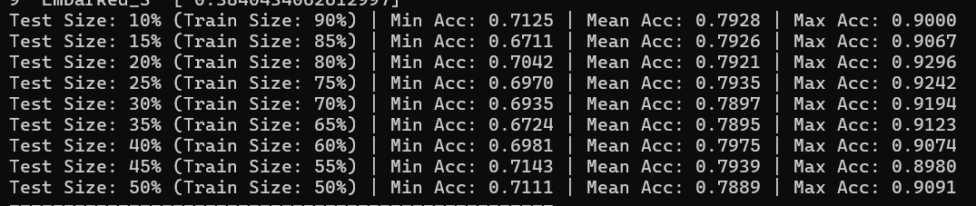

Mean accuracy is almost identical across all splits (0.789–0.798), so the model is stable regardless of split size. The 40% test split has the highest mean (0.7975), but the difference from the others is within noise (about 0.5 percentage points). The 70/30 split gives 0.790 and keeps a large training set, while the 75/25 and 80/20 splits (means 0.7935 and 0.7921) also perform well with more training data. I recommend 70/30 (as required) or 75/25 as a good balance of training data and a reliable test set; the minimum and maximum vary widely between folds because folds are small, which is why the mean is the more useful figure.

e.b Test results at 70/30 split
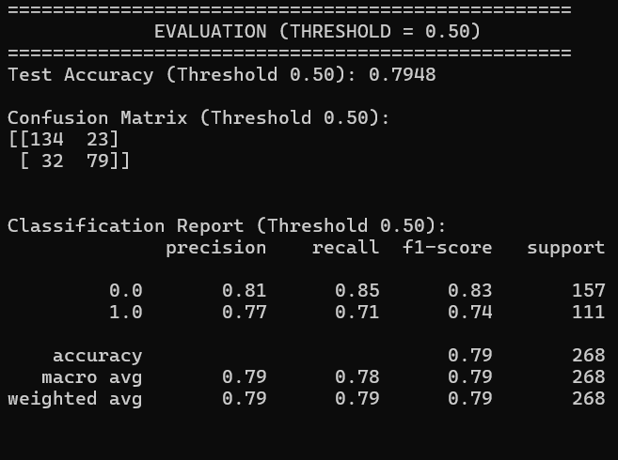
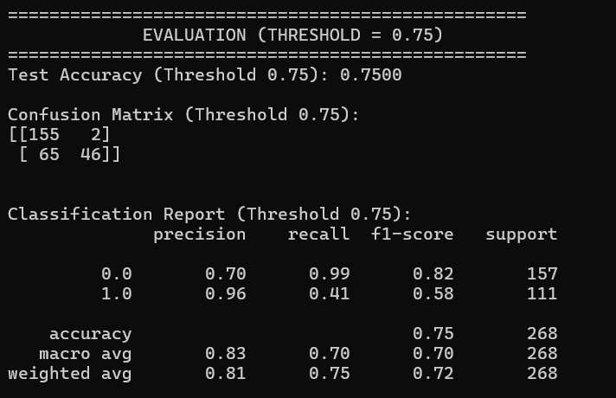

- Training vs. test accuracy: training accuracy is 0.799 and test accuracy is 0.795. They are very close, so the model is not overfitting and generalizes well.
- Threshold 0.5 vs. 0.75: raising the threshold makes the model predict “survived” only when it is very confident. Precision for survivors rises from 0.77 to 0.96 (almost every predicted survivor really survived), but recall for survivors drops from 0.71 to 0.41, so many true survivors are missed (false negatives rise from 32 to 65). Overall accuracy falls from 79.5% to 75.0%.
- Conclusion: the 0.5 threshold gives the better overall balance. A 0.75 threshold would only be preferable if false positives were far more costly than missed survivors.
AI Disclosure Statement
Yes. Tool: Claude (Anthropic).
Specified: test my output with requirements
Refine: The Python script and this report draft.

